Homework 2

**Due at the beginning of the class on May 29 (Tuesday)**

Answer the following questions as clearly as possible. Bullet points are fine. (TOTAL 100 Points)

* **Conceptual Questions:**

**Q1. (25 Points)**

1. (5 points) State the Heckscher-Ohlin Theorem.

**Solution:**

Under assumptions:

1. Both factors can move freely between the industries.

2. Production of one good is labor-intensive, and production of other good is capital-intensive.

3. Resources are unevenly distributed across the two countries; Foreign is labor abundant, and Home

4. The final outputs can be traded internationally, but L and K do not move between countries.

5. Across the two countries, each good is produced using the same technology

6. Consumer tastes are the same across countries

With two goods and two factors, each country will export the good that uses intensively the factor of production it has in abundance and will import the other good.

› K abundant country will export K intensive goods and import L intensive goods.

› L abundant country will export L intensive goods and import K intensive goods.

1. (10 points) How did Leontief test this theorem? What did he find?

**Solution:**

To test the Heckscher-Ohlin Theorem, Leontief used 1947 data for the United States and measured the amount of capital and labor required to produce $1 million worth of U. S. exports and $1 million worth of U. S. imports.

He found that the capital–labor ratio used in export production was $14,000 per worker and the capital–labor ratio for imports was $18,200 per worker. Because the United States is believed to be abundant in capital in 1947, the Heckscher-Ohlin theorem predicts that the United States would export capital-intensive goods and import labor-intensive goods. However, Leontief ’s findings, known as the “Leontief’s paradox,” indicated that the U.S. imports were capital-intensive and U. S. exports were labor-intensive.

1. (10 points) Does Leontief’s result hold after adjusting for differences in productivity? If yes, why? If no, why not? Explain.

**Solution:**

After adjusting for differences in productivity, Effective Labor Force = Actual L Force * Productivity of that L force. To measure whether a country is abundant in that effective factor or scarce in that effective factor: we now compare its share of the effective factor endowment with its share of world GDP.



By this method, we see that in 1947 the United States actually had 43 percent of the worlds “effective” labor and only 37 percent of world GDP, making the United States abundant in effective labor, and this solves the Leontief ’s Paradox.

**Q2.**  **(25 Points)**

Suppose Mexico receives an inflow of FDI. There are two factors (labor and capital), and two sectors (Food and Televisions). Televisions are capital intensive goods and Food is labor -intensive.

1. (10 points) Using a box diagram show how the inflow of FDI is going to affect the economy in the long run. Point out the pre- and post- FDI allocation of L and K in the Food and Televisions sector.

**Solution:**

Consider an extension of Heckscher-Ohlin Model.

Two factors: labor and capital.

Two sectors: Food and Televisions. Televisions (Food) are capital (labor) intensive.

All factors fully mobile within a country.

There is an inflow of capital.

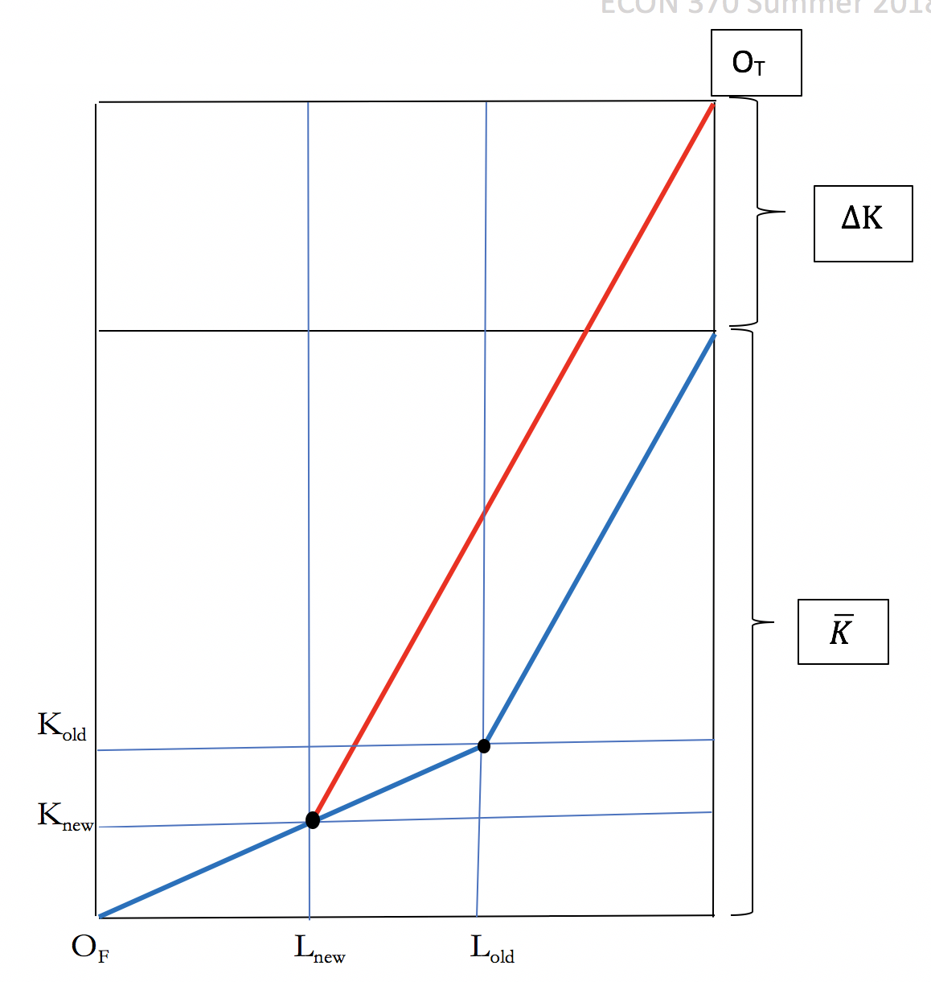

Pre-FDI allocation of L in the Food sector: OFLold

Pre-FDI allocation of K in the Food sector: OFKold

Pre-FDI allocation of L in the Televisions sector: OTLold

Pre-FDI allocation of K in the Televisions sector: OTKold

Post -FDI allocation of L in the Food sector: OFLnew

Post -FDI allocation of K in the Food sector: OFKnew

Post -FDI allocation of L in the Televisions sector: OTLnew

Post -FDI allocation of K in the Televisions sector: OTKnew

1. (10 points) How does factor earnings (Wage and Rentals on Capital) change due to the inflow of FDI? Explain.

**Solution:**

With no change in the capital/labor ratios across the two industries, the marginal productivity of the factors remains unchanged, as each L in each sector has same amount of capital to work with even after FDI, similarly each K in each sector has same amount of L to work with. As a result, the wage and the rental on capital remain unchanged.

1. (5 points) What happens to the output of each good? Show and explain using a graph.

**Solution:**

As the Rybczynski Theorem states, the increase in capital through FDI increases the output of the capital-intensive industry and reduces the output of the labor-intensive industry.

QF

Home PPFs

QT

* **Numerical Questions: (40 Points)**

**Q3.**

Suppose Spain uses only capital and labor for production of two goods, cars and shoes. There are total 150 workers and 100 units of capital in the economy. Cars use 3 units of capital for each worker, so that Kc = 3 * Lc, whereas shoes use 0.5 unit of capital for each worker, so that Ks = 0.5 * Ls.

1. (10 points) Solve for the amount of L and K used in each industry.

**Solution:**

Lc + Ls = 150 ……(1)

Kc + Ks = 100

* 3Lc + 0.5 Ls =100 … (2)

Solving (1) and (2):

Lc = 10

Ls = 140

Kc= 30

Ks= 70

1. (10 points) Suppose there is an inflow of 50 workers in the economy due to immigration, keeping total capital constant at 100. Solve for the amount of L and K used in each industry.

**Solution:**

Lc + Ls = 200 ……(1)

Kc + Ks = 100

* 3Lc + 0.5 Ls =100 … (2)

Solving (1) and (2):

Lc = 0

Ls = 200

Kc= 0

Ks= 100

1. (10 points) Suppose instead there is an inflow of 25 units of capital in the economy due to FDI, keeping total labor constant at 150. Solve for the amount of L and K used in each industry.

**Solution:**

Lc + Ls = 150 ……(1)

Kc + Ks = 125

* 3Lc + 0.5 Ls =125 … (2)

Solving (1) and (2):

Lc = 20

Ls = 130

Kc= 60

Ks= 65

1. (10 points) Explain how your results in parts (b) and (c) are related to Rybczynski Theorem.

**Solution:**

Rybczynski theorem states:

An increase in the amount of a factor found in an economy will increase the output of the industry using that factor intensively and decrease the output of the other industry.

In part (b), supply of labor goes up, allocation of labor in labor-intensive good goes up , and allocation of labor in capital-intensive good goes down, this leads to increase in production of labor-intensive good and decrease in production of capital-intensive good.

In part (c), supply of capital goes up, allocation of capital in labor-intensive good goes down, and that in capital-intensive good goes up, this leads to increase in production of capital-intensive good and decrease in production of labor-intensive good.

* **Empirical Questions: (10 Points)**

**Q4.**

1. (5 Points) What is/are the potential question(s) you are going to pursue in your Project?
2. (5 Points) What is the potential dataset you are going to use in your project?

Please see the “Project ideas by each student”, posted in the Project section on Blackboard!

Make sure your idea is different than others.